PROGRAMMING IN C

Lab File

SESSION – 2024 – 2027



Submitted to: Submitted by:
Silky Goel Anuska
SAP ID-59001635
BCA
BATCH – 5TH

INDEX

- Write a code to add two numbers also write the algorithm, pseudo code and draw flow chart.
- Write a code to find the area and circumference of a circle numbers, also write the algorithm, pseudo code and flow chart.
- Write a code to check whether the number is odd or even also write the algorithm, flow chart and pseudo code.
- Write a code to print first name, surname, birthyear in a sequence , also write the algorithm, flow chart and pseudo code.
- Write a code to print the simple interest, also write the algorithm, pseudo code and flowchart.
- Write a code for swapping two numbers using temporary variable also write the algorithm, flow chart and pseudo code.
- Write a code for swapping numbers without using temporary variable also write the algorithm, flow chart and pseudo code.

EXPERIMENT- 1
AIM: Write a code to find the sum of two numbers and write the algorithm, pseudo code and draw the flowchart.
SOURCE CODE:
#include<stdio.h>
int main( ) {
int a, b, sum;
printf (“Enter two integers”)
scanf (“%d %d”, &a &b);
sum = a+b;
printf (“%d + %d = %d”, a, b, sum);
}

OUTPUT:
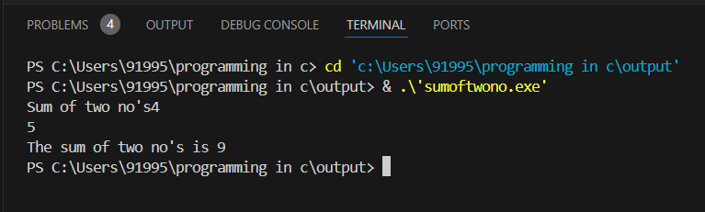

ALGORITHM:
Step 1: Start
Step 2: Read the first number.
Step 3: Read the second number.
Step 4: Add the two numbers using add operator.
Step 5: Display the result.
Step 6: Stop
FLOWCHART:
Read num 1
Print Sum
Stop
Start
Sum= num1 + num2
Read num 2

EXPERIMENT- 2

AIM: Write the program to calculate the area and circumference of the circle. Also write the algorithm, pseudo code and draw the flow chart.
SOURCE CODE:
- #include <stdio.h>
- #define PI 3.14159
- int main() {
- double radius, area, circumference;
- printf("Enter the radius of the circle: ");
- scanf("%lf", &radius);
- area = PI * radius * radius;
- circumference = 2 * PI * radius;
- printf("Area of the circle: %.2lf\n", area);
- printf("Circumference of the circle: %.2lf\n", circumference);
- return 0;
- }

OUTPUT:
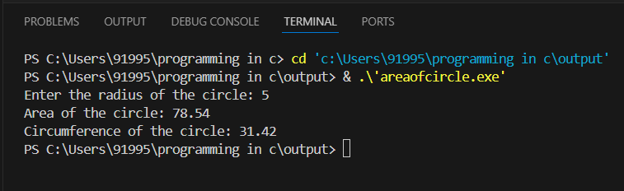

ALGORITHM:
• Start
• Input radius of the circle (r)
• Calculate area using the formula: Area = π * r^2
• Calculate circumference using the formula: Circumference = 2 * π * r
• Output the area and circumference
• Stop

FLOWCHART:
Print Area
Stop
Start
Print Circumference
Circumference=2*pi*radius
Area =pi*radius*radius
Let pi= 3.14
Read radius

EXPERIMENT- 3
AIM: Write a code to check whether the number is odd or even also write the algorithm, flow chart and pseudo code

SOURCE CODE:
#include <stdio.h>
int main(){
int num;
printf("Enter the number ");
scanf("%d", &num);
if (num % 2 == 0)
printf("%d Even",num);
else printf("%d odd",num);
return 0;
}

OUTPUT:
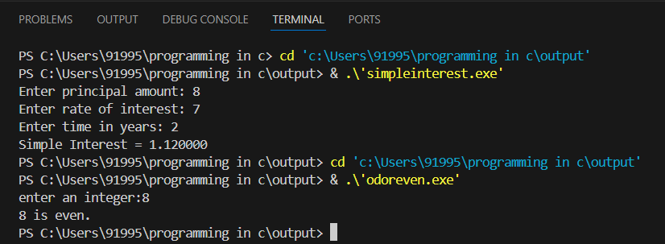

ALGORITHM:
Step 1: Start
Step 2: Take a number n from the user.
Step 3: Calculate remainder by using n%2.
Step 4: If the remainder is 0 print “even”
Step 5: If the remainder is not 0 print “odd”
Step 6: Stop

FLOWCHART:
Enter a number n
If n%2==0
Start

YES
NO
Number is odd
Stop
Number is even

EXPERIMENT- 4
AIM: Write a code to print first name, surname, birthyear in a sequence , also write the algorithm, flow chart and pseudo code.

SOURCE CODE:
#include<stdio.h>
int main()
{
char firstname[20],surname[20];
int birthyear;
printf("Enter first name: ");
scanf("%s",&firstname);
printf("Enter surname: ");
scanf("%s",&surname);
printf("Enter birthyear: ");
scanf("%d",&birthyear);
printf("%s ",firstname);
printf("%s",surname);
printf("\n%d",birthyear);
return 0;
}

OUTPUT:
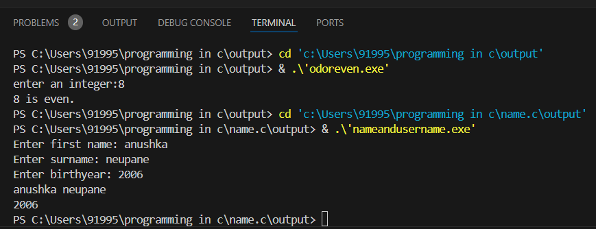

ALGORITHM:
Step 1: Start
Step 2: Take first name from the user
Step 3: Take surname from the user
Step 4: Take birthyear from the user
Step 5: Print name
Step 6: Print surname
Step 7: Print birthyear
Step 8: Stop
FLOWCHART:
Enter surname
Start
Print “First name”
Enter birthyear
Enter first name

Print “Surname”
Print “Birthyear”
Stop

EXPERIMENT – 5

AIM: Write the program for calculating the simple interest. Also write the algorithm, pseudo code and draw the flow chart.

SOURCE CODE:
#include <stdio.h>

int main() {
float principal, rate, time, si;
printf("Enter principal amount: ");
scanf("%f", &principal);
printf("Enter rate of interest: ");
scanf("%f", &rate);
scanf("%f", &time);
si = (principal * rate * time) / 100;
printf("Simple Interest = %f", si);
return 0;
}

OUTPUT:
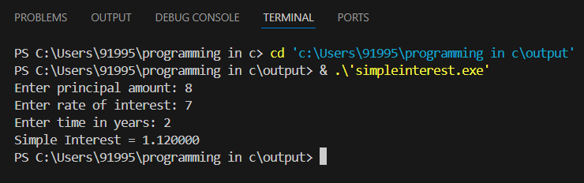

ALGORITHM:
Step 1: Start
Step 2: Take P from the user
Step 3: Take R from the user
Step 4: Take T from the user
Step 5: Calculate Simple Interest using the formula P*R*T/100
Step 6: Display Simple Interest
Step 7: Stop

FLOW CHART:
Start
Enter P
Enter T
S.I=P*R*T/100
Print S.I
Stop
Enter R

